

AP Assignment 3

**aliza asif**

22BCS50175

22BCS_FL_IOT_601_A

**AP ASSIGNMENT 3**

**Q1.** **Binary Tree In order Traversal (94)**

Implementation Code:

class Solution { public:

vector<int> inorderTraversal(TreeNode* root) { vector<int> result;

stack<TreeNode*> stack; TreeNode* current = root;

while (current != nullptr || !stack.empty()) { while (current != nullptr) {

stack.push(current); current = current->left;

}

current = stack.top(); stack.pop(); result.push_back(current->val); current = current->right;

}

return result;

}

};

Output:

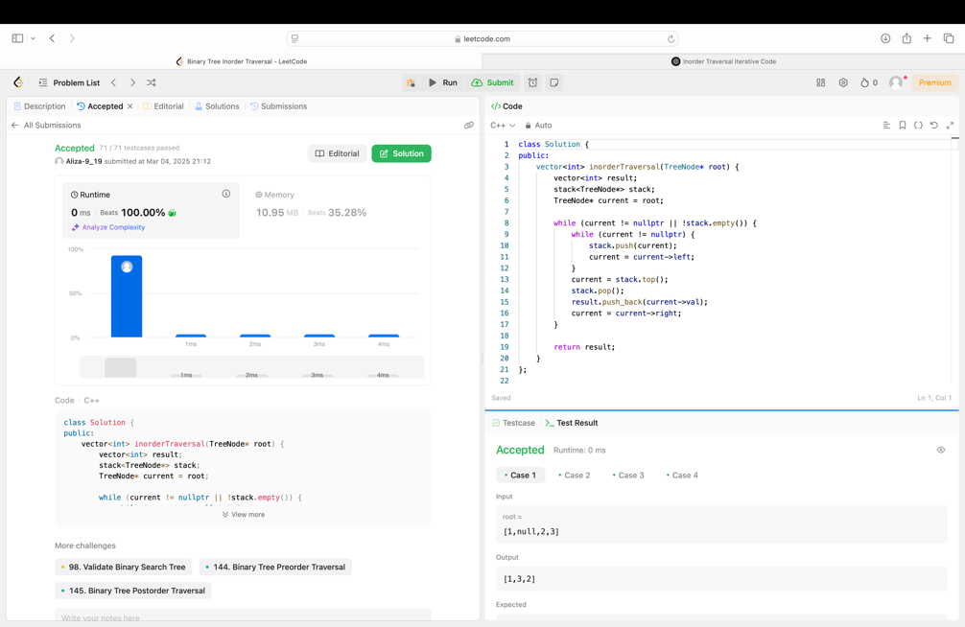

**Q2. Symmetric Tree (101)**

Implementation Code:

class Solution {

public:

bool isSymmetric(TreeNode* root) {

return isMirror(root, root);

}

bool isMirror(TreeNode* t1, TreeNode* t2) {

if (!t1 && !t2) return true;

if (!t1 || !t2) return false;

return (t1->val == t2->val)

&& isMirror(t1->left, t2->right)

&& isMirror(t1->right, t2->left);

}

};

Output:

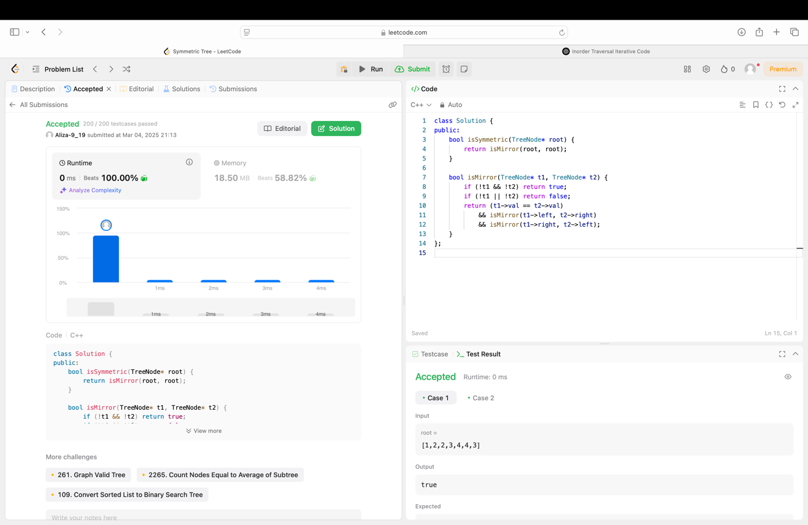

**Q3. Maximum Depth of Binary Tree (104)**

Implementation Code:

class Solution {

public:

int maxDepth(TreeNode* root) {

if (root == nullptr) {

return 0;

}

int leftDepth = maxDepth(root->left);

int rightDepth = maxDepth(root->right);

return max(leftDepth, rightDepth) + 1;

}

};

Output:

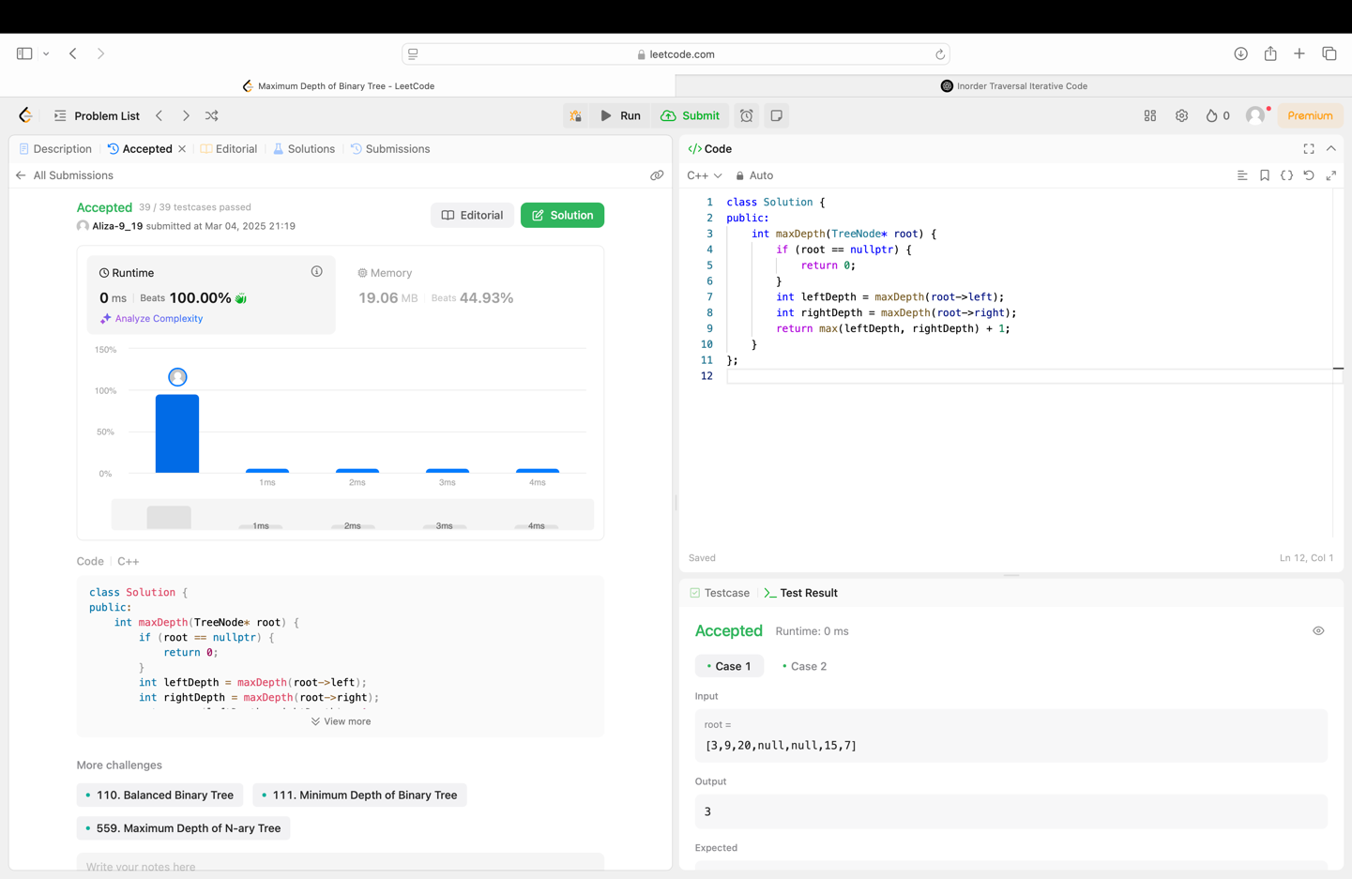

**Q4. Validate Binary Search Tree (98)**

Implementation Code:

class Solution {

public:

bool isValidBST(TreeNode* root, TreeNode* minNode = nullptr, TreeNode* maxNode = nullptr) {

if (root == nullptr) {

return true;

}

if (minNode != nullptr && root->val <= minNode->val) {

return false;

}

if (maxNode != nullptr && root->val >= maxNode->val) {

return false;

}

return isValidBST(root->left, minNode, root) && isValidBST(root->right, root, maxNode);

}

};

Output:

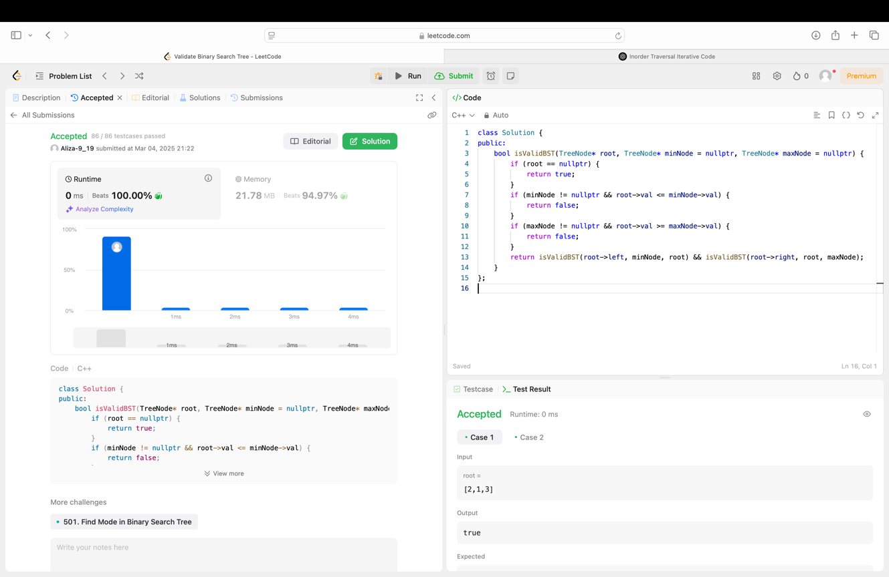

**Q5. Kth Smallest Element in a BST (230)**

Implementation Code:

class Solution {

public:

int kthSmallest(TreeNode* root, int k) {

stack<TreeNode*> stack;

TreeNode* current = root;

int count = 0;

while (current != nullptr || !stack.empty()) {

while (current != nullptr) {

stack.push(current);

current = current->left;

}

current = stack.top();

stack.pop();

count++;

if (count == k) {

return current->val;

}

current = current->right;

}

return -1;

}

};

Output:

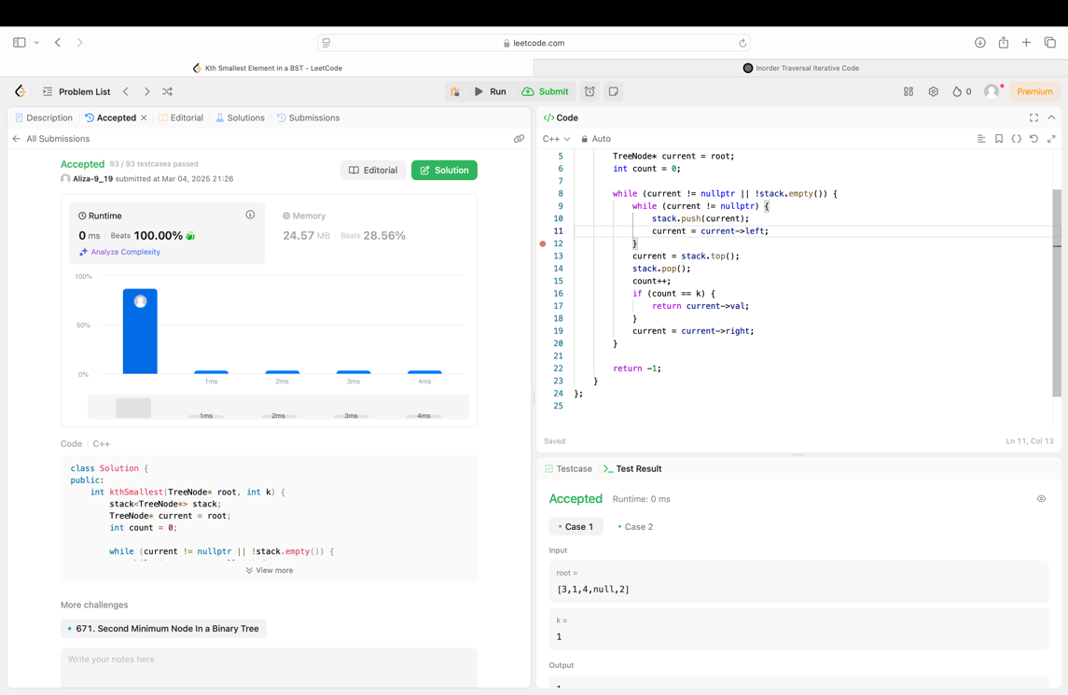

**Q6. Binary Tree Level Order Traversal (102)**

Implementation Code:

class Solution {

public:

vector<vector<int>> levelOrder(TreeNode* root) {

vector<vector<int>> result;

if (root == nullptr) return result;

queue<TreeNode*> q;

q.push(root);

while (!q.empty()) {

int levelSize = q.size();

vector<int> level;

for (int i = 0; i < levelSize; ++i) {

TreeNode* node = q.front();

q.pop();

level.push_back(node->val);

if (node->left) q.push(node->left);

if (node->right) q.push(node->right);

}

result.push_back(level);

}

return result;

}

};

Output:

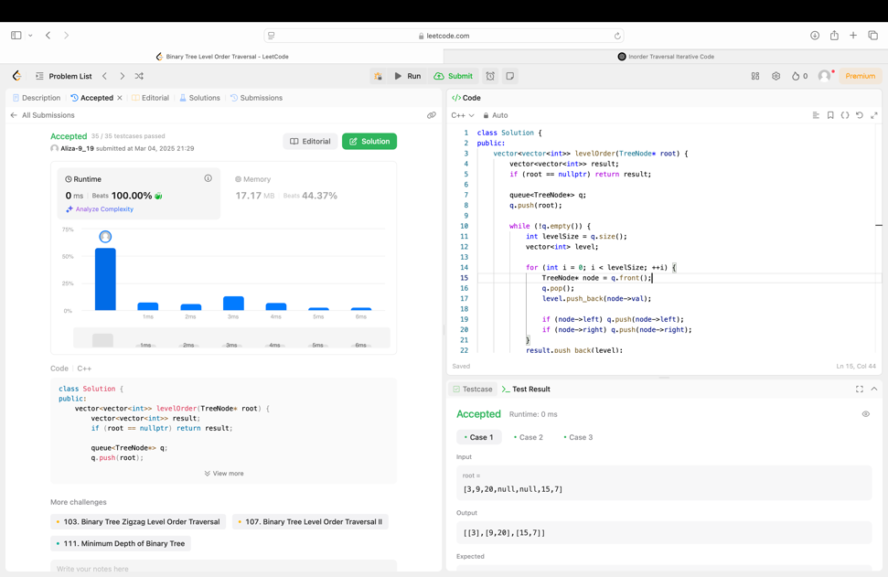

**Q7. Binary Tree Level Order Traversal II (107)**

Implementation Code:

class Solution {

public:

vector<vector<int>> levelOrderBottom(TreeNode* root) {

vector<vector<int>> result;

if (root == nullptr) return result;

queue<TreeNode*> q;

q.push(root);

while (!q.empty()) {

int levelSize = q.size();

vector<int> level;

for (int i = 0; i < levelSize; ++i) {

TreeNode* node = q.front();

q.pop();

level.push_back(node->val);

if (node->left) q.push(node->left);

if (node->right) q.push(node->right);

}

result.push_back(level);

}

reverse(result.begin(), result.end());

return result;

}

};

Output:

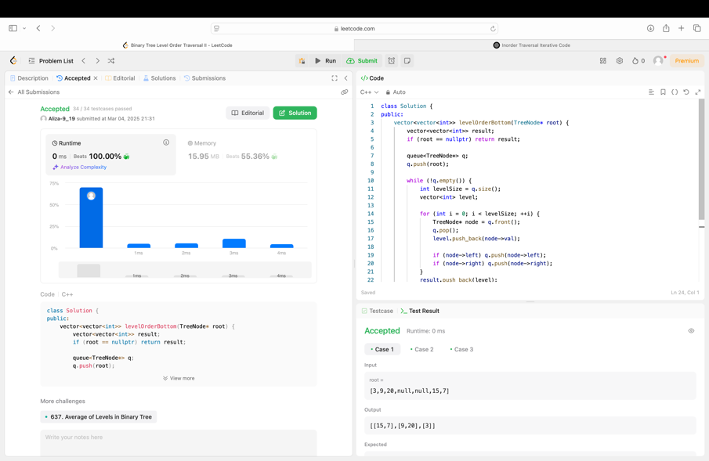

**Q8. Binary Tree Zigzag Level Order Traversal (103)**

Implementation Code:

class Solution {

public:

vector<vector<int>> zigzagLevelOrder(TreeNode* root) {

vector<vector<int>> result;

if (root == nullptr) return result;

queue<TreeNode*> q;

q.push(root);

bool leftToRight = true;

while (!q.empty()) {

int levelSize = q.size();

vector<int> level(levelSize);

for (int i = 0; i < levelSize; ++i) {

TreeNode* node = q.front();

q.pop();

int index = leftToRight ? i : (levelSize - 1 - i);

level[index] = node->val;

if (node->left) q.push(node->left);

if (node->right) q.push(node->right);

}

result.push_back(level);

leftToRight = !leftToRight;

}

return result;

}

};

Output:

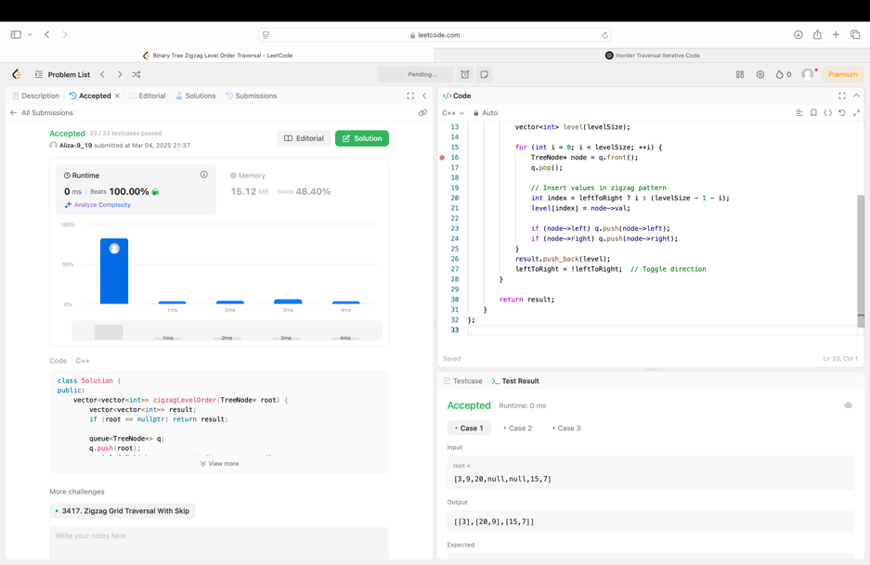

**Q9. Binary Tree Right Side View (199)**

Implementation Code:

class Solution {

public:

vector<int> rightSideView(TreeNode* root) {

vector<int> result;

if (!root) return result;

queue<TreeNode*> q;

q.push(root);

while (!q.empty()) {

int levelSize = q.size();

for (int i = 0; i < levelSize; ++i) {

TreeNode* node = q.front();

q.pop();

if (i == levelSize - 1) {

result.push_back(node->val);

}

if (node->left) q.push(node->left);

if (node->right) q.push(node->right);

}

}

return result;

}

};

Output:

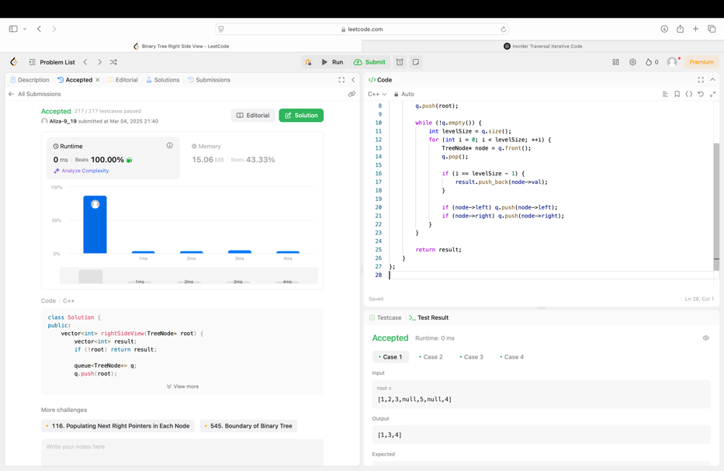

**Q10. Construct Binary Tree from Inorder and Postorder Traversal (106)**

Implementation Code:

class Solution {

public:

TreeNode* buildTree(vector<int>& inorder, vector<int>& postorder) {

unordered_map<int, int> inorderMap;

for (int i = 0; i < inorder.size(); ++i) {

inorderMap[inorder[i]] = i;

}

return buildTreeRecursive(inorder, postorder, inorderMap, 0, inorder.size() - 1, 0, postorder.size() - 1);

}

TreeNode* buildTreeRecursive(vector<int>& inorder, vector<int>& postorder, unordered_map<int, int>& inorderMap,

int inStart, int inEnd, int postStart, int postEnd) {

if (inStart > inEnd || postStart > postEnd) return nullptr;

int rootVal = postorder[postEnd];

TreeNode* root = new TreeNode(rootVal);

int rootIndex = inorderMap[rootVal];

int leftTreeSize = rootIndex - inStart;

root->left = buildTreeRecursive(inorder, postorder, inorderMap, inStart, rootIndex - 1, postStart, postStart + leftTreeSize - 1);

root->right = buildTreeRecursive(inorder, postorder, inorderMap, rootIndex + 1, inEnd, postStart + leftTreeSize, postEnd - 1);

return root;

}

};

Output:

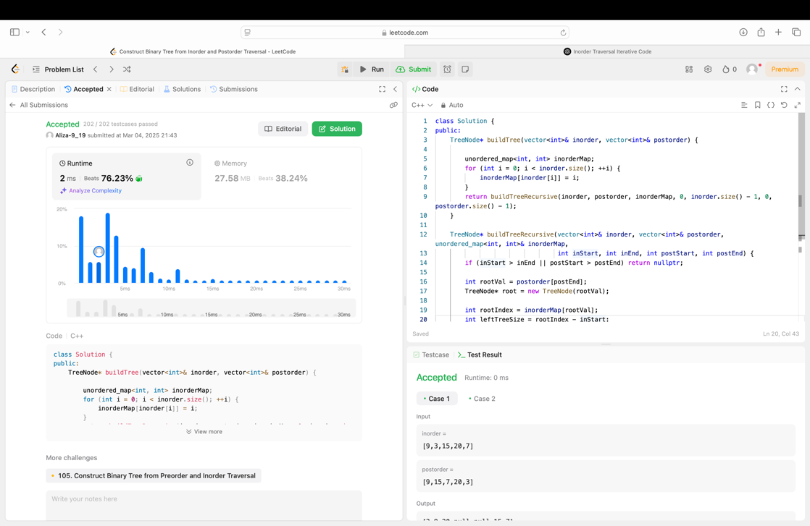

**Q11. Find Bottom Left Tree Value (513)**

Implementation Code:

class Solution {

public:

int findBottomLeftValue(TreeNode* root) {

queue<TreeNode*> q;

q.push(root);

int leftmostValue = root->val;

while (!q.empty()) {

int size = q.size();

leftmostValue = q.front()->val;

for (int i = 0; i < size; ++i) {

TreeNode* node = q.front();

q.pop();

if (node->left) q.push(node->left);

if (node->right) q.push(node->right);

}

}

return leftmostValue;

}

};

Output:

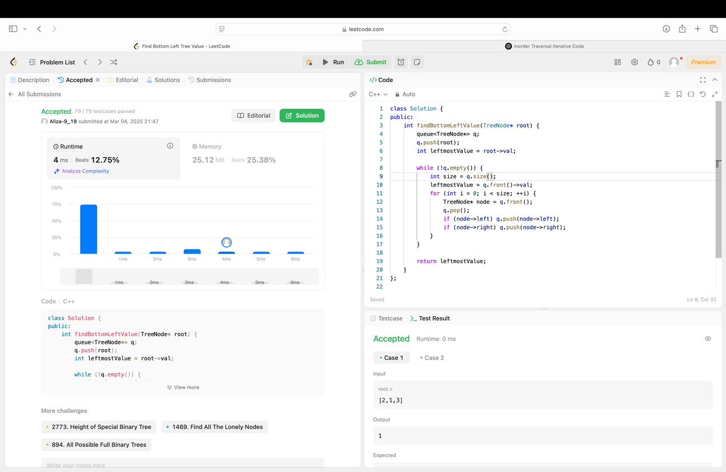

**Q12. Binary Tree Maximum Path Sum (214)**

Implementation Code:

class Solution {

public:

int maxPathSum(TreeNode* root) {

int maxSum = INT_MIN;

maxGain(root, maxSum);

return maxSum;

}

int maxGain(TreeNode* node, int& maxSum) {

if (node == nullptr) return 0;

int leftGain = max(maxGain(node->left, maxSum), 0);

int rightGain = max(maxGain(node->right, maxSum), 0);

int priceNewPath = node->val + leftGain + rightGain;

maxSum = max(maxSum, priceNewPath);

return node->val + max(leftGain, rightGain);

}

};

Output:

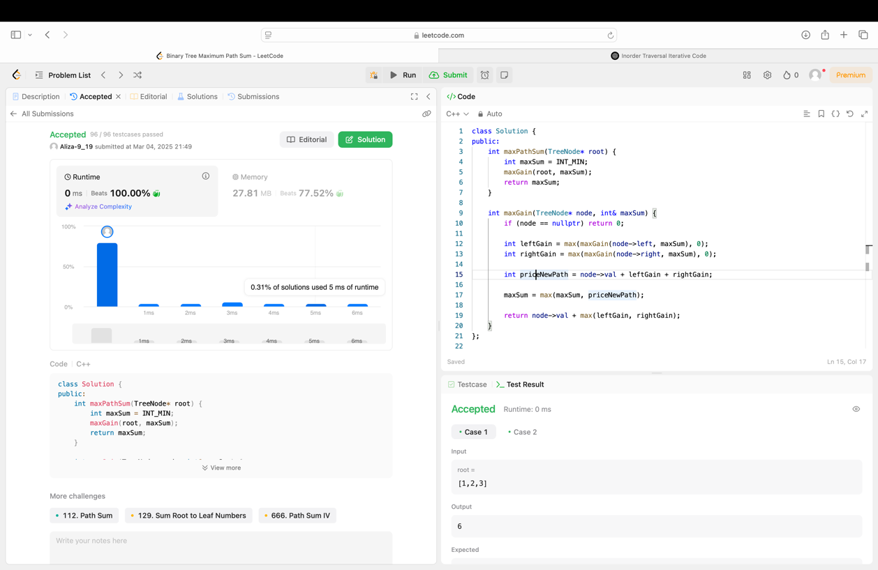

**Q13.** **Vertical Order Traversal of a Binary Tree (987)**

Implementation Code:

class Solution {

public:

vector<vector<int>> verticalTraversal(TreeNode* root) {

map<int, map<int, multiset<int>>> nodes; // col -> (row -> set of node values)

queue<pair<TreeNode*, pair<int, int>>> q; // node -> (row, col)

q.push({root, {0, 0}});

while (!q.empty()) {

auto p = q.front();

q.pop();

TreeNode* node = p.first;

int row = p.second.first, col = p.second.second;

nodes[col][row].insert(node->val);

if (node->left) q.push({node->left, {row + 1, col - 1}});

if (node->right) q.push({node->right, {row + 1, col + 1}});

}

vector<vector<int>> result;

for (auto& p : nodes) {

vector<int> col;

for (auto& q : p.second) {

col.insert(col.end(), q.second.begin(), q.second.end());

}

result.push_back(col);

}

return result;

}

};

Output:

